**Vol. 2; Issue 1: Jan - Mar 2019**

**ISSN: 2582-2748**

**Research Article (www.ijrams.com)**

INTERNATIONAL JOURNAL OF RESEARCH IN AYURVEDA AND MEDICAL SCIENCES

**RANDOMIZED CONTROLLED STUDY THE EFFICACY OF *PIPPALYADI YOG* IN THE MANAGEMENT OF *STANYAKSHAYA*.**

# Bali Swati Bhagwan.1*

1. M.S. (Prasutitantra-Streerog), Assistant Professor, Dept. of Prasutitantra-Streerog, Shiva Trust’s Y.C.A.M. Nipani Bhalgaon, Beed-bypass road, Aurangabad, Maharashtra, India.

**Received on: 11/01/19; Revised on: 19/01/19; Accepted on: 21/01/19**

**ABSTRACT**

Ideal form of feeding and nourishing the baby is Breast feeding. Ayurveda describes decreased breast milk as *‘Stanyakshaya’*. Main cause of *Stanyakshaya* found is *Rasadhatu Kshaya*. Lactation failure is defined as low milk output in mother, inadequate to meet baby’s requirements. Deficient Lactation is quite common now-a- days. Stanyakshya has both *Shareerika* and *Manasika nidanas. Shaeerik nidanas* includes *Langhana, Shrama*, *Rukshannapana;* while *Manasik nidana include Krodh, Shoka,* and *Avatsalya* i.e. not having affection towards child which can be compared same in modern with milk secretion and milk ejection processes (Prolactin re- flex & Oxytocin reflex) respectively. In modern aspect there is limited treatment modalities and having their side effects. Therefore, in present study *Pippalyadi Yog* described by the *Aacharya Harit* was selected**.** Tab. Metoclopramide was used as control drug for study. Result of the study shows that the *Pippalyadi Yog* and Tab. Metoclopramide both are effective in treating *Stanyakshaya*. Statistical analysis done by Wilcoxon sign rank test at level of significance 5%, has shown highly significant results as value of p is less than 0.05 in all symptoms. Mann-Whitney’s U Test applied for comparative effect, has shown insignificant results as value of p is more than 0.05 in all symptoms. This suggests that both treatments were equally effective to reduce symp- toms of *Stanyakshaya*.

**Keywords:** *Stanyakshaya, Pippalyadi Yog,* Deficient Lactation.

# INTRODUCTION

An infant should be exclusively breastfed till six months of age. During this age, additional food or fluid is not required as breast milk is nutritionally complete for the child’s growth and development and it protects from infections and strengthens immune system.**1** Breast milk secretion 300ml/day by the 5th day and 480ml/day by the 10th day has been termed as adequate lactation. If these amounts are not achieved then situation is termed clinically as lacta- tion deficiency. A healthy-looking, alert baby with good muscle tone and good skin elasticity who is producing at least six to eight wet nappies per day is a good indicator of adequate intake.**2**

In Ayurveda many *aacharyas* explained the importance of Stanya. According to Ayurveda, food after digestion produces *Rasa dhatu* and *Stanya* is *Prasad bhaga* of *Rasa dhatu. Stanya* is produced and collected in *Stanyashaya.***3** According to different

*Acharyas Stanya utpatti* is described from *Rasa,* from *Rakta* or from *Raja***4, 5**. For proper milk ejection unin- terrupted affection for the child is mainly responsi- ble.**6** Stanya is perfect food for infant as contains best of all nutrients helpful for the child growth. The *Stan- ya* is said to possess qualities such as *Pushtikara, Vruddhikara, Bala Vardhana*.**7**

*Aacharya Kashyapa* says that the pure milk is that which provides unobstructed, easy and good growth of strength, different body parts, longevity as well as good health to the child and does not cause any pain or trouble to the child and wet nurse.**8** Ayur- veda describes decreased breast milk as *‘Stanyakshaya’*. Detail description of *Stanyakshaya* is found in *Bruhat-trayi* and also described in detail by *Aacharya Kashyap, Harit, Chakrapani* and *Bhavpra- kash. Stanyakshaya* is associated with *Rasadhatu Kshaya*. The cause of *Stanyakshaya***9** includes both *Shareerika* and *Manasika nidanas* as *Shrama, Langhana, Rukshannapana, Krodh, Shoka,* and

|  |
| --- |
| INTERNATIONAL JOURNAL OF RESEARCH IN AYURVEDA AND MEDICAL SCIENCES |
| **Research Article (www.ijrams.com) ISSN: 2582-2748 Vol. 2; Issue 1: Jan - Mar 2019** |
| **\*Corresponding Author: Bali Swati Bhagwan.**  M.S. (Prasutitantra-Streerog), Assistant Professor, Dept. of Prasutitantra-Streerog, Shiva Trust’s Y.C.A.M. Nipani Bhalgaon, Beed-bypass road, Aurangabad, Maharashtra, India. Email – [baliswati9@gmail.com](mailto:baliswati9@gmail.com) . |

*Avatsalya* i.e. not having affection towards child which can be compared same in modern with Prolac- tin reflex i.e. milk secretion and Oxytocin reflex i.e. milk ejection respectively.

Main factors in *samprapti* of *Stanyakshaya* are *Agnimandya* and *Vata dosha prakop*. Ksheena Rasa dhatu and Rakta Dhatu also have effect in caus- ing *Stanyakshaya*. In *Sutika Avastha*, there is *Ag- nimadya* due to *Dhatukshay, Kledadhikya* and *Dosh prakop Samprapti Ghataka* producing *Stanyakshaya* can be stated as*:* ***Dosha:*** *Pran, Apana* and *Samana Vayu, Kledak Kapha;* ***Dushya:*** *Stanya, Rasa Dhatu, Rakta Dhatu;* ***Srotas:*** *Stanyavaha, Rasavaha, Rak- tavaha;* ***Udbhava:*** *Amashaya;* ***Rogamarga:*** *Bahyya Rogamarga;* ***Adhisthana:*** *Garbhashaya;* ***Vyak- tisthana:*** *Stana.*

Effects of *Stanyakshaya* can be seen in both mother and child. Clinical features of *Stanyakshaya* in mother were include Laxity of breast along with decrease in quantity or absence of milk secretion**10**. If babies not get adequate breast milk, will have symp- toms like *Atripti* (Hunger), *Apatarpan* (Failure to gain weight), *Kuposhan* (Malnutrition), *Nidranasha* (disturbed sleep), *Adhika rodan* (More crying) etc.**11** For the management of *Stanyakshaya*, ayurvedic treatment which have multiplied over the recent years, which is non-hormonal, non-surgical, effec- tive, safer & without any adverse effects is the need- ed. Ayurveda describes various drugs & preparations for the treatment of *Stanyakshaya*. Ayurvedic drugs are comparatively safe without unwanted reaction and easily available.

Faulty secretion or absence of breast milk after child- birth is termed as ‘Agalactorrhea’ or ‘Agalactia’. Lactation failure is defined as low milk output in mother, inadequate to meet baby’s requirements. Lack of self-confidence, primigravida’s and teen mothers (inexperience), mental anxiety and physical stress of workload in working women, Incorrect breast-feeding practices, Insufficient secretion due of lack of sleep, fatigue, anxiety and inadequate fluid intake are the main causes of the Failure of Lactation. Many galactagogues preparations like special foods and drinks are claimed to increase milk production, by providing normal nutrition and increasing prolac- tin secretion. However most of them found working by placebo effect. The best galactagogue is nutritious diet to mother and healthy, exclusively-demand-fed baby, vigorously sucking in correct position**12**. Ac- cording to modern science, Metoclopramide drug is

prescribed for improving breast milk secretion.**13** But it has other adverse effects like fatigue, insomnia, depression, anxiety, etc.

Keeping these aspects in mind, this study has been undertaken. According to *Harit Samhita Magadhi, Nagari, Pathya, Gud, Ghrit* and *Kshir* were used in *Stanyakshaya*. Hence it is an attempt to verify the claim that *‘Pippalyadi Yog’***14** is Galactagogue.

# METHODS

* 1. **Objectives**
* To study efficacy of *Pippalyadi Yog* in *Stan- yakshaya.*
* To study the *Samprati* and *Samprapti ghataka* of

*Stanyakshaya.*

* To review the literature available on *‘Pippalyadi Yog’* and its ingredients in detail.
* To compare the efficacy of *Pippalyadi Yog* and Tab. Metoclopramide in *Stanyakshaya*.

# Ethical Clearance

Institutional Ethical Committee of our Institute pro- vided Ethical clearance certificate for the present study.

# Study Design

60 patients were selected randomly by simple randomized sampling procedure. They further divid- ed in two groups viz. Group A and Group B. The study was carried out on OPD basis in the ‘Dept of Prasutitantra and Strirog’ of our Institute. Type of study was Randomized Control Study.

# Criteria for selection of the patients

Patients of age between 18 to 35 years and irrespective of religion, sex and occupation, patients from 5th day of post-partum up to 6 months, patients with history of lactational deficiency. Patients having breast milk quantity less than 300 ml/day and willing to give consent for study were included.

Patients of age below 18 years and above 36 years, patients with other pathologies like Breast en- gorgement, cracked or sore nipples, mastitis, flat / inverted nipples and history of breast trauma or breast surgery were excluded. Mother having history of hormonal disorders or under hormonal therapy and mother of baby having cleft lip, cleft palate or disor- ganized suck reflex were excluded. Those patients

with breast milk production below 50ml /day and patients not willing to participate in the study and those who discontinued treatment were also exclud- ed.

# Drug Review

* + 1. ***Pippalyadi Yog14***

**Contents:** *Shunthi, Pippali, Haritaki, Guda, ghrit, Godugdha.*

***Karmukatva*:** *Karmukatva* of *Pippalyadi Yog* is de- scribed in Table No. 1.

**Method of preparation of *Yog*:** *Churna* was pre- pared as per *Churna Kalpana***15** as mentioned in Sha- rangdhar Samhita.

# Tab. Metoclopramide

Tab. Perinorm 10mg BD of Ipca Laboratories Phar- macy were used for control group patients.

# Administration of the Drugs

Group A individuals were given *Pippalyadi Yog* and Group B individuals were given Tab. Metoclo- pramide. Details of Drug administration are men- tioned in Table No. 2.

# Assessment Criteria

For assessing the symptoms before and after treatment, all symptoms were graded. Gradation of symptoms are mentioned in Table No.3. According to total relief symptoms patients were divided into 4 groups as mentioned in Table no 4.

# RESULTS AND DISCUSSION

* 1. **General Observations**

All collected data was classified and present- ed in the form of tables and analyzed to draw inter- ferences. Age group i.e. 24-30 years were found more (70%) it shows s*tanyakshaya* observed more in elderly mothers. Multiparous women affected more (55%) than primigravida. The service women (41.6%) and labor workers (25%) were mostly af- fected, may be due to mental stress, continuous work load, more physical work and improper diet may be the causative factors. More percentage of patients having post-partum period 5 to 60 days observed.

In group A 12 patients (40%) have shown

excellent improvement and 17 patients (56.66%) have shown moderate improvement and 1 patient (3.33%) have shown mild improvement. In group B 7 patients (23.33%) have shown excellent improve- ment, 15 (50%) patients have shown moderate im- provement and 8 patients (26.66%) have shown mild improvement, as shown in Table no 4. It was ob- served that *‘Pippalyadi Yog’* found more efficient in *Stanyakshaya* than Tab. Metoclopramide.

# Statistical Analysis

Finally, results were analyzed statistically using Wil- coxon sign rank test at level of significance 5%. In Trial Group, in case of all symptoms value of P was less than 0.05 (Table No. 5). In Control Group, in case of all symptoms value of P was also less than

0.05 (Table No. 5). As per statistical analysis it was concluded that,

Both *Pippalyadi Yog* and tab. Metoclopramide were significantly effective to improve Breast milk ejec- tion, Breast feeding Frequency, Frequency of mictu- rition of baby, Weight gain of child & Milk produc- tion Volume in *Stanyakshaya*.

When compared effects of both groups using Mann Whitney test, in case of all symptoms value of P was greater than 0.05 (Table No. 6). As per statistical analysis it was concluded that,

*Pippalyadi Yog* and Tab. Metoclopramide both were equally effective to improve Breast milk ejection, Breast feeding Frequency, Frequency of micturition of baby, Weight gain of child & Milk production Volume in *Stanyakshaya*.

* 1. **Mode of Action of *Pippalyadi Yog***

The chief *Dosha* involved in *Stanyakshaya* is *Vata dosha*. *Agnimandya* plays an important role in samprapti of Stanyakshaya. Ksheena Rasadhatu and Raktadhatu also have effect in causing Stan- yakshaya. According to Properties of drugs Pippal- yadi Choorna is having Katu, Madhur rasa, Madhur vipaka, Sheet veerya and Laghu, Snighdha guna. Katu Rasa of the drugs will act on the vitiated Ra- sadahtu and corrects jatharagnimandya. Madhur Ra- sa does tarpan of rasa dhatu and helps in Stan- yajanan and vardhan.

With help of all these properties, *Pippalyadi Yog* helps in *Agnideepana*, *Aampachana & Stan-*

*yajanana.* Hence it is found to be good Galacta- gogue.

# Scope and Limitations

Present study was carried out on a smaller number of subjects in limited area hence having its self- limitations. There is further scope to carry out trials on large sample size.

# CONCLUSION

* Prevalence of Stanyakshaya found more in pa- tients having Vata-pittaj prakruti, Visham Agni and Krura Koshtha because Vata is main dosha in causing Stanyakshaya.
* More prevalence also found in patients delivered by LSCS than those delivered by normal labour. Also, service women and students affected more may be because of continuous work load, improp- er diet, mental stress.
* *Pippalyadi Yog* and Tab. Metoclopramide both are equally effective in management of *Stan- yakshaya*.
* *Pippalyadi Yog* is safe treatment as there is no any adverse effect observed during the study Tab. Metoclopramide has its adverse effects.
* *Stanyakshaya* can be successfully treated by Ayurvedic treatment.

# REFERENCES

1. O.P. Ghai, Vinod K Paul, Arvind Bagga. Ghai Essential Pediatrics. Seventh ed. New Delhi: CBC Publishers and Distributors Pvt Ltd; Reprint 2010. p. 60.
2. Available from, [https://www.medela.ca/breast](https://www.medela.ca/breastfeeding/advice/breastfeeding-tips/%20normal-breastfeeding) [feeding/advice/breastfeeding-tips/normal-breast](https://www.medela.ca/breastfeeding/advice/breastfeeding-tips/%20normal-breastfeeding) [feeding.](https://www.medela.ca/breastfeeding/advice/breastfeeding-tips/%20normal-breastfeeding) Last accessed on 28/12/2018.
3. Kaviraj Ambikadutta Shastri Editor(s), (Eleventh ed.). Sushrutsamhita of Aacharya Sushruta, Ni- danasthana; Visarpanadistanaroganidanam: Chap- ter 10, Verse 19. Varanasi: Chaukhambha San- skrit Sansthan, 1997; p.269.
4. Dr. Bramhananda Tripathi Editor(s), (Reprint ed.). Charaka Samhita of Agnivesha vol II of Dr. Bramhananda Tripathi, Chikitsasthana; Gra- hanidosha Chikitsa: Chapter 15, Verse 17. Vara- nasi: Chaukhambha Surbharti Prakashan, 2011; p.553.
5. Pandit Hemaraj Sharma Editor(s), (Reprint ed.). Kashyap Samhita of Vriddha Jivaka, Sutrasthana; Lehaadhyaya: Varanasi: Chaukhambha Publica-

tion, 2006; p.2.

1. Kaviraj Ambikadutta Shastri Editor(s), (Eleventh ed.). Sushrutsamhita of Aacharya Sushruta, Ni- danasthana; Visarpanadistanaroganidanam: Chap- ter 10, Verse 22-23. Varanasi: Chaukhambha San- skrit Sansthan, 1997; p.270.
2. Pandit Hemaraj Sharma Editor(s), (Reprint ed.). Kashyap Samhita of Vriddha Jivaka, Khilsthana; Kshirgunavisheshiyaadhyaya: Chapter 22, Verse

10. Varanasi: Chaukhambha Publication, 2006; p.355.

1. Pandit Hemaraj Sharma Editor(s), (Reprint ed.). Kashyap Samhita of Vriddha Jivaka, Sutrasthana; kshirotpattiadhyaya: Chapter 19, Verse 26. Vara- nasi: Chaukhambha Publication, 2006; p.9.
2. Kaviraj Ambikadutta Shastri Editor(s), (Eleventh ed.). Sushrutsamhita of Aacharya Sushruta, Sharirasthana; Garbhinivyakaranam Sharir: Chap- ter 10, Verse 34. Varanasi: Chaukhambha Sanskrit Sansthan, 1997; p.201.
3. Kaviraj Ambikadutta Shastri Editor(s), (Eleventh ed.). Sushrutsamhita of Aacharya Sushruta, Su- trasthana; Doshadhatumalakshayavruddhi vid- nyaniyam: Chapter 15, Verse 16. Varanasi: Chau- khambha Sanskrit Sansthan, 1997; p.59.
4. Pandit Hemaraj Sharma Editor(s), (Reprint ed.). Kashyap Samhita of Vriddha Jivaka, Kalpasthana; Bhojankalpa: Varanasi: Chaukhambha Publica- tion, 2006; p.210.
5. O.P. Ghai, Vinod K Paul, Arvind Bagga. Ghai Essential Pediatrics. Seventh ed. New Delhi: CBC Publishers and Distributors Pvt Ltd; Reprint 2010. p. 128.
6. Metaclopromide; available from, [https://](https://www.drugs.com/breastfeeding/metoclopra%20mide.html) [www.drugs.com/breastfeeding/metoclopramide.](https://www.drugs.com/breastfeeding/metoclopra%20mide.html) [html.](https://www.drugs.com/breastfeeding/metoclopra%20mide.html) Last accessed on 30/12/2018.
7. Vaidya Jaymini Pandey Editor(s), (First ed.). Harita Samhita of Aacharya Harita, Trutiyasthana; Sutikarog Chikitsa:Chapter 53, Verse 4. Delhi: Chaukhambha Books, 2010; p.479.
8. Brahmanand Tripathi Editor(s), (Reprint ed**.**). Sharangdhara Samhita of Sharangdhara, Madh- yama khanda; Choorna-kalpana Adhyaya: Chapter 6, Verse 1. Varanasi: Chaukhamba Subharati Pra- kashana, 2004; p. 172.

# Source of Support: Nil; Conflict of Interest: None declared.

**6. TABLES**

|  |  |  |  |  |  |  |
| --- | --- | --- | --- | --- | --- | --- |
| **Sr.**  **No.** | **Name of Drug** | ***Rasa*** | ***Virya*** | ***Vipaka*** | ***Guna*** | ***Karma*** |
| **1.** | *Pippali* | *Katu* | *Sheet* | *Madhur* | *Laghu, Snigdha* | *Kapha-vata shamak* |
| **2** | *Shunthi* | *Katu* | *Anushna* | *Madhur* | *Laghu, Snigdha, Tikshna* | *Kapha-vata shamak* |
| **3** | *Haritaki* | *Lawan varjit Pancha Rasa, Kashaya Pradhan* | *Ushna* | *Madhur* | *Laghu Ruksha* | *Tridosha- shamak* |
| **4** | *Guda* | *Madhur* | *Sheet* | *Madhur* | *Guru, Snigdha* | *Tridosha- shamak* |
| **5** | *Ghrit* | *Madhur* | *Sheet* | *Madhur* | *Guru, Snigdha, Mrudu* | *Vata-pitta shamak* |
| **6** | *Godugdha* | *Madhur* | *Sheet* | *Madhur* | *Guru, Snigdha, sheet* | *Vata- pitta shamak.* |

**Table No 1** Contents and therapeutic properties of *Pippalyadi Yog.*

|  |  |  |  |
| --- | --- | --- | --- |
| **Sr. No.** | **Head** | ***Pippalyadi Yog*** | **Tab. Metoclopramide** |
| **1** | **Route** | Oral | Oral |
| **2** | ***Matra*** | 5 gm | 10 mg |
| **3** | ***Kala/Avadhi*** | *Pragbhakta* BD | Before meal BD |
| **4** | ***Anupan*** | *Godugdha* | *water* |
| **5** | **Duration** | 45 days | 45 days |
| **6** | **Follow ups** | Day 15, 30, 45 | Day 15, 30, 45 |

**Table No 2** Details of Administration of drugs

|  |  |  |  |  |
| --- | --- | --- | --- | --- |
| **Sr.**  **No.** | **Symptom** | **Description** | | **Grade** |
| **1.** | Breast milk ejection | Forceful Stream like Drop by drop  No milk | | 0  1  2  3 |
| **2.** | Breast feeding  frequency | 8-12 times / day 6-7 times / day 4-5 times / day 2-3 times / day | | 0  1  2  3 |
| **3.** | Frequency of micturition of baby | 7-8 times / day 5-6 times / day 3-4 times / day 0-2 times / day | | 0  1  2  3 |
| **4.** | Weight gain of child | 5th day - 4 months | 4-6 months |  |
| 30 gm / day 20 gm / day 10 gm / day  Less than 10 gm / day | 20 gm / day 15 gm / day 10 gm / day  Less than 10 gm / day | 0  1  2  3 |

|  |  |  |  |
| --- | --- | --- | --- |
| **5.** | Milk production volume | Above 400 ml / day Up to 300 ml / day Up to 200 ml / day From 50-100 ml / day | 0  1  2  3 |

**Table No 3** Gradations of Assessment criterion of *Stanyakshaya*.

|  |  |  |  |  |
| --- | --- | --- | --- | --- |
| **Sr.**  **No.** | **Improvement Grade** | **Criteria** | **No of Patients** | |
| **Group A** | **Group B** |
| **1** | Extreme Improvement | 75% to  100% | 12 | 7 |
| **2** | Moderate Improvement | 50% to 75% | 17 | 15 |
| **3** | Mild Improvement | 25% to 50% | 1 | 8 |
| **4** | Poor Improvement | 00% to 25% | 0 | 0 |

**Table No 4** Total Effect of Therapy

|  |  |  |  |  |  |
| --- | --- | --- | --- | --- | --- |
| **Sr.**  **No.** | **Symptom** | **Group** | **W** | **P** | **Significance** |
| **1** | Breast milk ejection | **Trial** | 435 | <0.0001 | Significant |
| **Control** | 351 | <0.0001 | Significant |
| **2** | Breast feeding fre- quency | **Trial** | 465 | <0.0001 | Significant |
| **Control** | 406 | <0.0001 | Significant |
| **3** | Frequency of  micturition of baby | **Trial** | 465 | <0.0001 | Significant |
| **Control** | 435 | <0.0001 | Significant |
| **4** | Weight gain of child | **Trial** | 465 | <0.0001 | Significant |
| **Control** | 465 | <0.0001 | Significant |
| **5** | Milk production volume | **Trial** | 435 | <0.0001 | Significant |
| **Control** | 406 | <0.0001 | Significant |

**Table No 5** Statistical Analysis in Trial Group & Control Group (Wilcoxon sign rank test)

|  |  |  |  |  |  |
| --- | --- | --- | --- | --- | --- |
| **Sr. No.** | **Symptom** | **U Value** | **P** | **Significance** | **Result** |
| **1** | Breast milk ejection | 409.5 | 0.539 | Not significant | A≈B |
| **2** | Breast feeding frequency | 420 | 0.658 | Not significant | A≈B |
| **3** | Frequency of micturition of baby | 394.5 | 0.409 | Not significant | A≈B |
| **4** | Weight gain of child | 443 | 0.922 | Not significant | A≈B |
| **5** | Milk production volume | 409.5 | 0.549 | Not significant | A≈B |

**Table No 6** Statistical Analysis to compare Trial Group & Control Group (Mann-Whitney test) (**‘≈’ means statistically equal and not exactly equal)**

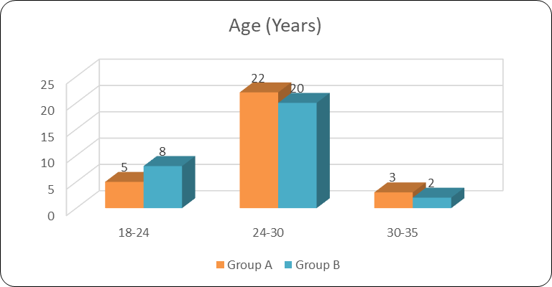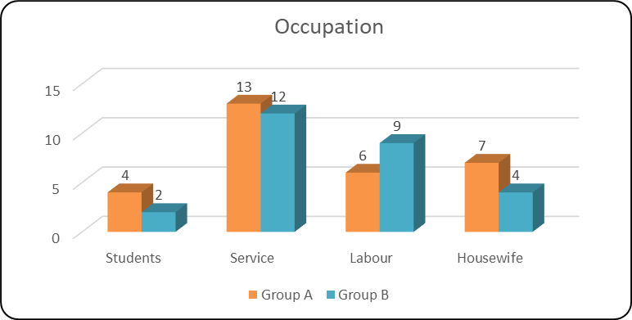

**Figure No 1** Age wise distribution **Figure No 2** Occupation wise distribution

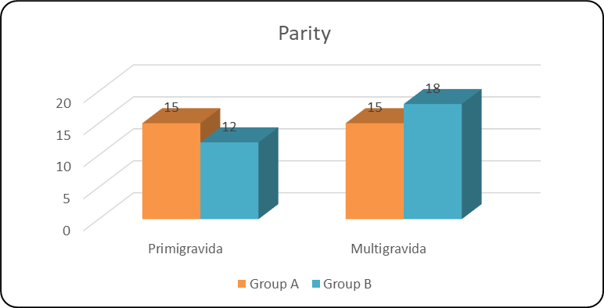

**Figure No 3** Parity wise distribution

**Cite this article as:**

Bali SB. Randomized Controlled Study the efficacy of Pippalyadi Yog in the management of Stanyakshaya. International Journal of Research in Ayurveda and Medical Sciences 2019; 2 (1): 15-21.